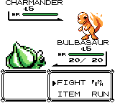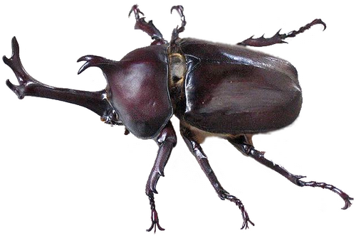

*This* ***insect*** *is a stag beetle.*

**The Story of Satoshi Tajiri**

“I got it!” said Satoshi Tajiri in the park near his house. “This is an interesting insect.”

Satoshi lived in Machida in Tokyo. Machida did not have many buildings and many trees grew there.

“Hey, Dr. Bug! What are you doing?” asked Satoshi’s friend. Satoshi liked that name. “I am catching insects. You should try. It is very fun. We can catch many kinds of insects here.” Satoshi said.

Many people started to live in Machida. The forests became small, so Satoshi could not insects. But he remembered it. Satoshi played games then. He liked games very much.

Later, in 1990, Satoshi was 25 years old. He was writing for magazines. He wrote about games. He also had an idea.

“This is a great idea for a game. Players will catch many interesting animals,” said Satoshi. “They will use the animals to play the game!” The main character was Satoshi, and the second character was Shigeru. (Shigeru Miyamoto made Mario!)

It was 1996. “Many people in Japan love this game. But, will American game players love it, too?” people asked. “I think we should change the characters.”

“No,” said Satoshi, “this game is great. People will love it!” Shops in America sold the first Pokémon games in 1998. Many people around the world love Pokémon now.