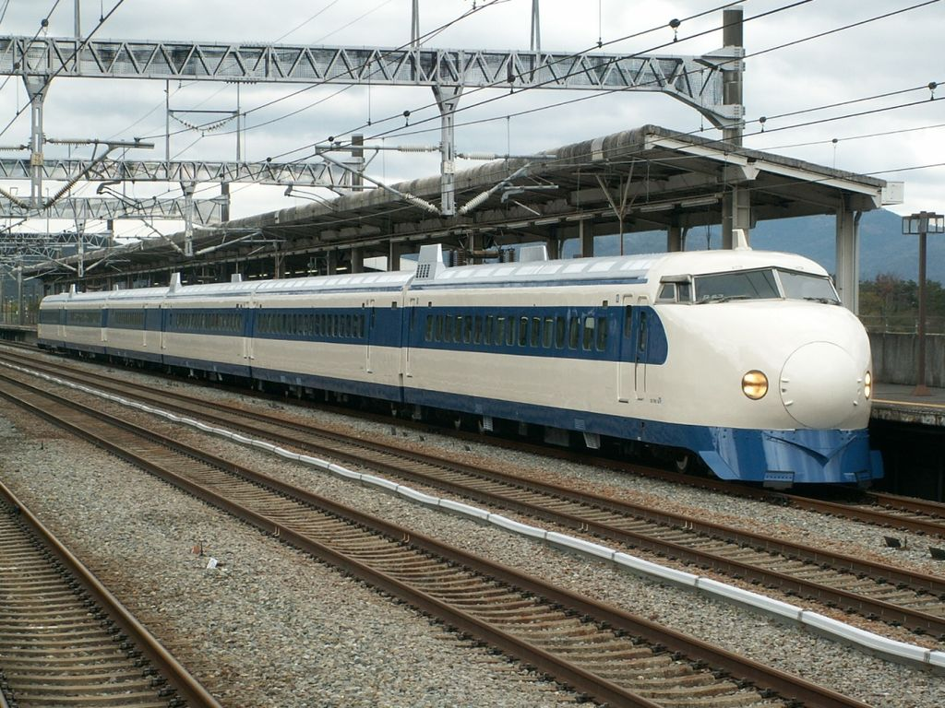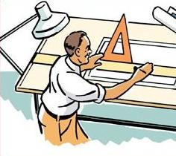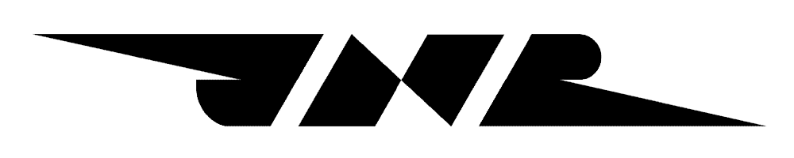

*In English we call this a* ***bullet train****.*

***Engineers*** *make many things.*

**The Story of Hideo Shima**

“I must leave,” said Hideo Shima, “I am going to go to a new company.”

“I am sad, but I understand,” said Shinji Sogo.

Hideo was an engineer for Japan National Railways. Shinji was the leader of Japan National Railways. Hideo was leaving Japan National Railways because of a big accident that happened in Yokohama in 1951.

In 1955 Shinji talked with Hideo again. “Hideo, we have a new idea. We will make a train that will be very fast. We cannot make the train without you.”

“I will try,” said Hideo. Hideo and his team worked very hard. They wanted to make a safe train. “We need a safe train. People will not ride a dangerous train,” he said.

But there was a problem. “A fast train cannot turn left or right. The train must go straight,” Hideo said. “That will take a lot of money.”

Hideo used too much money. Again, Hideo had to leave Japan National Railways because he used too much money and the company was not happy.

Hideo said, “Will the train be safe? Will people like this train?”

Yes. It was a great train and it was the first high speed train line in the world. Now people in many countries know and love this train, the *bullet train*.