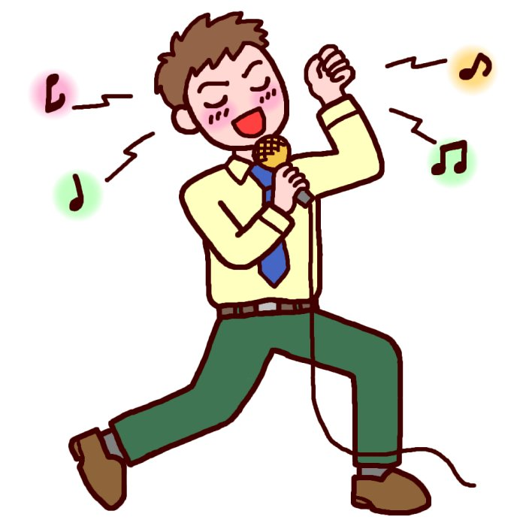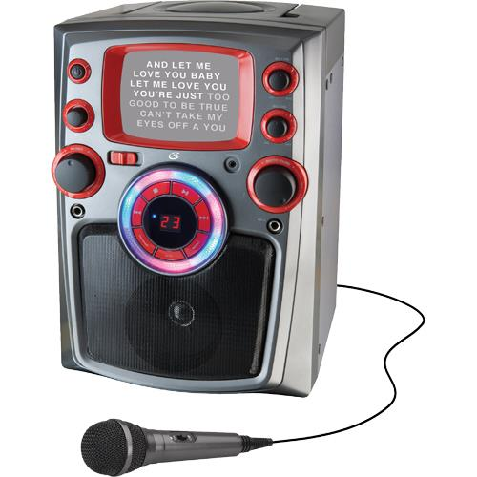

Global Studies: 2-4 story 2 of 6

**The Daisuke Inoue**

Daisuke Inoue lived in Osaka. He loved to play music and he had a band. His band was not famous, but they did interesting work.

“Daisuke, my company will have a party next week. We want to sing at the party. Will your band please come and play music? Then we can sing?” asked Mr. Tamura.

“Sure! We always like to play for you and your friends. Will you give me a list of songs?” said Daisuke.

After a few weeks Mr. Tamura talked to Daisuke again. “Daisuke, I am going to have another party. Will you come and play? Then we can sing again?” asked Mr. Tamura. “The party will be on Saturday.”

Daisuke had a problem. “I am sorry. We cannot play because we have to go to another party,” Daisuke said.

Daisuke thought a lot. What should he do? Daisuke thought for a long time, then he had a great idea!

“Mr. Tamura, I will show you something and you will be very happy. My band recorded music for you. Now you can play the music and sing at your party!” Daisuke said.

Mr. Tamura tried the new invention. It worked very well. The party was great!

“Maybe many other people will like this invention, too!” Daisuke said. In 1971 some shops in Kobe used his invention. Soon after that the Karaoke machine became popular all over Japan, then the world!