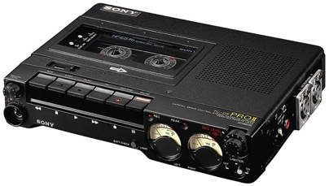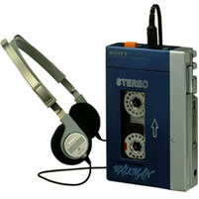

Global Studies: 2-4 story 1 of 6

*The* ***Sony TC-D5*** *was big and heavy.*

**The Story of Masaru Ibuka and Nobutoshi Kihara**

“Oh, no. I have to go to America again!” said Masaru Ibuka. “The trip is always too long and the airplane is not interesting!”

Masaru was an important person and a co-founder of Sony.

“What can I do? What do I like?” he thought. “I know! I love music. I listen to music every day. I can listen to music on the airplane!”

But the year was 1978. Music players were very big. For example, the Sony TC-D5 was very big and very heavy.

Masaru went to Nobutoshi Kihara, an engineer at Sony.

“Nobutoshi, I have a problem,” said Masaru.

“I am not sure. But, maybe I can help you,” said Nobutoshi, “Please tell me your problem.”

“I must fly to America many times each year. But it is not interesting. I like music. But music players are too big,” said Masaru. “What can you do?”

Nobutoshi worked very hard. Then he showed his work to Masaru. “Look!” he said, “it is a small music player. You can listen to music on the airplane!”

Masaru tried the new music player. The trip to America took 13 hours. The music player stopped after 6 hours, but Masaru was very happy.

“We have to share this idea with everyone!” Masaru said. People could by the first Sony Walkman in 1979 and music around the world changed.